Data Science Project Protocol

Machine Learning Model for prediction of algal growth, using maritime observatory

Author(s): Dalit Roth Rosenberg

Introduction
The marine microalgae are the primary producers that responsible for almost 50% of the earth oxygen, and the base of the marine food web. While microalgae growth is important to understand global cycles and the interactions between marine organisms, other aspects such as algal bloom are also being highly investigated. Harmful algal blooms (HABs) identified by rapid accumulation and increased concentration of the microalgal population. Blooming which usually occur due to excess in nutrients, affect the environment and may cause a dramatic depletion of oxygen, reduction in light and excretion of harmful toxins that may affect the whole trophic levels.

What is known about the problem?
HABs specially threatened coastal areas and are often associated with large-scale marine mortality events. Thus, HABs are being extensively studied by the National Centers for Coastal Ocean Science and Scientists use a range of technologies to predict where and when HABs are likely to form and how they will affect the areas where they occur.
While the East Mediterranean Levant is highly oligotrophic (low in nutrient) and massive blooms are less frequent, rapid algal growth indeed occurs. Thereby, understanding the biotic and abiotic factors leading to this extreme growth may be valuable.

Our goal is to build a model that can predict the growth of microalgae in the marine environment 24 hours in advanced. In addition, I hope that this model will explicitly explain some of the essential factors (geophysical and environmental) that influence algal growth leading to blooming.

What is known to influence the outcome?
-It is known that algae blooms are influenced by high nutrients availability with optimal temperature and light conditions.
-Increased nutrient loading from human activities are linked to severity of blooming frequent.
-HABs are a predictable seasonal occurrence resulting from coastal upwelling, a natural result of the movement of certain ocean currents.
-Phytoplankton growth varies seasonally. In high latitudes (East Mediterranean Sea), blooms peak in the spring and summer, when sunlight increases and the relentless mixing of the water by winter storms subsides.
-blooming may be genre-specific and be dominant during different time of the year.
-Winds play a strong role in the distribution of phytoplankton because they drive currents that cause deep water, loaded with nutrients, to be pulled up to the surface.

How do I define the outcome(s)?
A proxy for algal level is Chlorophyll A (chlA). ChlA is the main pigment in all photosynthetic organisms and can be monitored routinely by sensors or remote sensing (satellite). These measurements can be indirectly shown as chlA concentration (ug/L). For our model formation I will use the chlA measurements that were obtained by the Texas A&M - Haifa Eastern Mediterranean Marine Observatory (THEMO1) sensor (…), which is positioned at the edge of the continental shelf at ~125m depth (33.04°N, 034.95°E). THEMO1 produces data samples simultaneously from 32 40 sensors every 30 min.

Do I have any possible new knowledge that has not been in use before?
Generally, environmental models use signals such light, temperature and nutrients to predict the seasonality of algal bloom in a scale of months and seasons. However, THEMO1, which provides a high resolution of meteorological and geophysical data (e.g. temperature, humidity, turbidity, salinity, waves intensity, winds speed) may deepen our understanding on important processes taken place at the microscale levels (hours). These changes may give more precise prediction within few hours to one day, which can be very useful to inform fishermen, swimmers and others ahead of time.

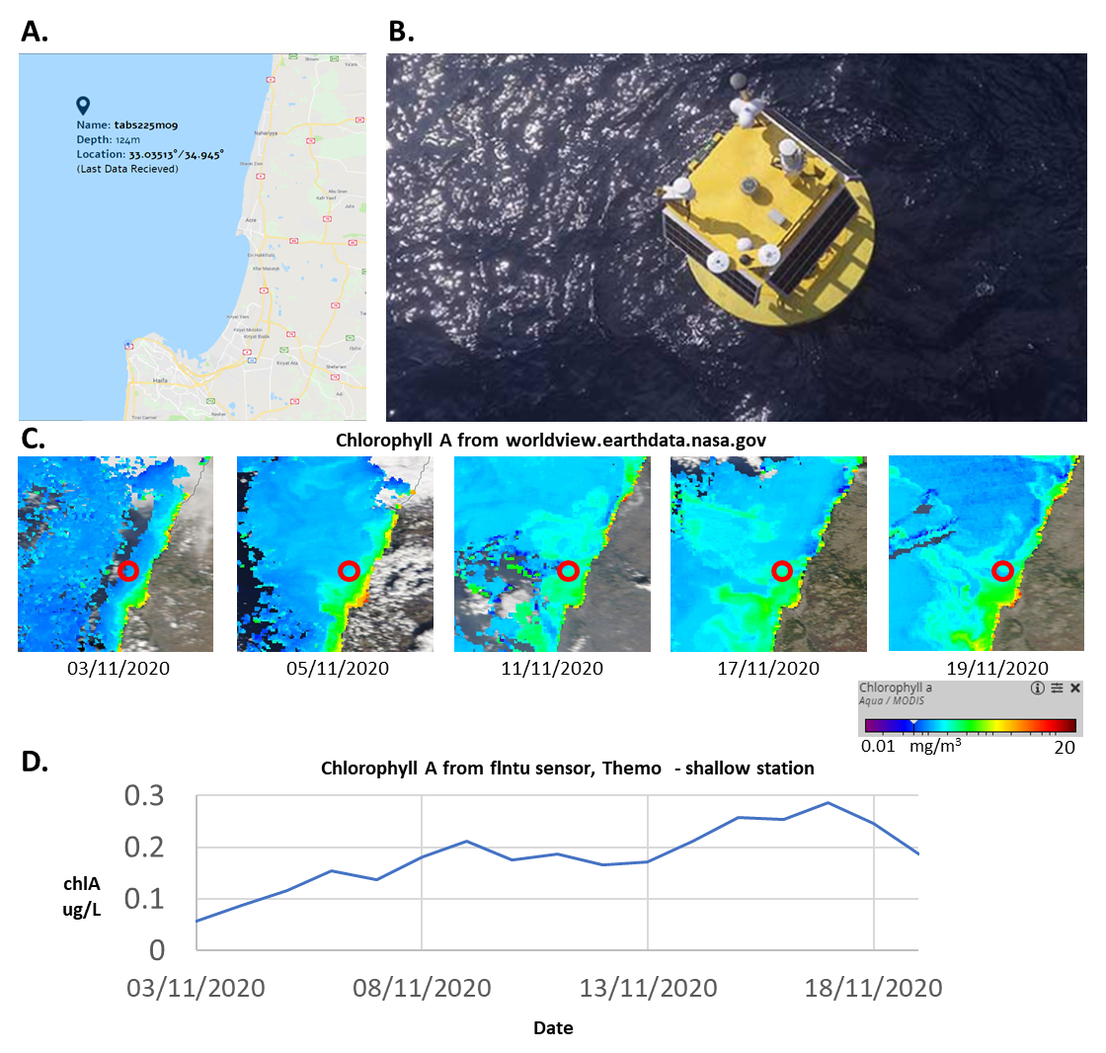
Figure 1. THEMO observatory and algal growth within time. A. show the location of the THEMO (B). C. shows the change in algal growth (satellite view) during two weeks. D. show the change in algal concentrations, during the same days, which are similar to satellite measurements.

Methodology (Project design)

Data
I have collected data from sensors that are located on THEMO1. Table 1. describes the information regarding each of the sensors (Data retrieval protocol and informative description of the parameters are presented at the appendix). To build the model, I have collected all the measurements that could be retrieved from each of the sensor, these measurements are presented in the appendix retrieval table :

External and internal data sources
In order to base our model mainly on THEMO1's sensors, I defined the sensors as the "core" or internal source of the model that would be joined as Flat File (by rounded time) and external data that would be added independently.

The outcome feature chl_pred
In order to train the model to predict algal growth 24 hours ahead, I used the chlorophyll_concentration as the outcome feature, from the next 24 hours (48 points later) and added 48 new rows to the end of the dataset.

Table 1. THEMO1 sensors information.

External data sources that may enrich our data

Since solar time is one of the important parameters that affect photosynthetic organisms' growth, I collected the following values: Sunrise Time (LST), Sunset Time (LST), Sunlight Duration (minutes), True Solar Time (min) and Sun Declin (deg) for each date in our time series. The data was calculated with the "NOAA_Solar_Calculations_year" calculator file that can be found on the NOAA website. To retrieve the values, I added the coordinates of the THEMO1, the time zone and the exact date. Note, that this date-location-specific solar information, can be used as a tool to represent a cyclic and seasonal information for data related to date and location on earth (appendix.).

Preparation of the data:

Data source | Feature name | Treatment
flntu | Chl_pred, chlorophyll_concentration, | Values <0 changed to 0 (technical problem0 | python
All tables | D_stamp | Converted to date | SQL
All tables | T_stamp | time | SQL
depth_xxx(depth) | Above threshold limits | Change all the 46.34 and 46.340 values into null. | python

Dataset time frames periods
Our dataset, which is a time series, contained data and measurements that were collected every 30 min (48 samples a day). The total dataset of ~19000 samples.

Variables that may affect the outcome
From THEMO sensors, there are some variables that might affect algal growth:
Direct effect | Indirect effect
Surface currents | Wind magnitude
Salinity | Humidity
Water temperature | conductivity
Turbidity | Barometric pressure
Water currents | Air temperature
 | waves

A diagram of those connection is presented in figure 2.

There are some variables that affect the growth directly and indirectly, one of them is water temperature which affect the algal physiologically (optimal growth range) and the environment physically (affect water stratification therefor density).

Figure 2. Dependencies datasets measured in THEMO (Diamant R. at al, 2020)

There are also some relationships between data measurements. For example, some anomalies in temperatureare shown to correlate at different depths.
Figure 3. Temperature data at three water depth measured in THEMO (Diamant R. at al, 2020)

Explanatory Data analysis
I I used pandas' describe method- to look at descriptive statistics parameters such as mean, median, min, max and percentile. I was mostly interested in features that their min and max values looked suspicious (negative values, very high or low values, zeros).
For visualization and analysis of the features I I used sweetviz. The distribution of features was evaluated visually (e.g. sns.distplot was used to show y distribution before and after transformation of all minuses to 0) . Features also were shown in boxplot to get a visual representation of their outliers.
Features with missing values were identified by isnull().sum()), lower number of counts and sweetwiz. I used this information to remove features with more than 90% missing. Heatmap and correlation matrix showed missing pattern and relationship between features that were important later on with the decision making whether these missing are random.
In order to get features patters in time, consistency, gaps and many more informative features, I used a plot representation against index. The pattern of gaps and correlation
To plot pairwise relationships I I used seaborn.pairplots. To get a sense on correlations between features, I I used spearman correlation function (y distribution is not normal) and sns.heatmap. I I identified features which had very high correlation between them to be addressed later.

Data enrichment
The enrichment of the data was divided into variables that were treated before and after retrieval into the Flat File and was applied by different methods and applications. The description of each enriched feature presented in the following table.

Feature name | Data source | Description/remark | Treatment | platform
Before
g_x(depth) | temperature | Depths temperature from S9 sensor | Transpose of temperature values to columns according to depths | SQL
depth_x(depth) | speed[m/s] | Depths doppler reads from ADCP sensor | Transpose of doppler values to columns according to depths | SQL
T_round1 | All the sensors | Retrieved from t_stamp | Round the time to the closest 30 min (0 or 30) to join tables. | SQL
After
'minute',  'hour' | T_round1 | Transform a time feature into numeric | divide the date into day and month | python
'T_round2' | T_round1 | Transform a time feature into numeric but split the day into two halves | create another hour column (12 h) and am/pm column | python
'am/pm' | T_round2 |  | create am/pm column | python
'year',  'month',  'day' | d_stamp | Transform a date feature into numeric | divide the date into day and month | python
"avg_g", "std_g" | g_x | High Stdv and var of temp in water column indicate mixing or mix layer which related to upwelling of nutrient/season/algae growth | calculated average and stdev out of temperature at different depths. | python
Sun_Declin_deg  Sunrise_Time_LST  Sunset_Time_LST  True_Solar_Time _min  Sunlight_Duration_minutes | "NOAA_Solar_Calculations_year.xls" |  | Added coordinates, time zone, and dates.  The values of those features were added manually to df_merge1_row_sun2.csv | python
'L/D' | 'T_round1  'Sunrise_Time_LST'  'Sunset_Time_LST' | Add day/light hours, as 0/1 calculated from sunlight hours. | 'T_round1 between  'Sunrise_Time_LST'  'Sunset_Time_LST' than 1. | python
'seasonality2'  'seasonality12'  'seasonality24'  'seasonality48'  trend2  trend12  trend24  trend48 | 'chlorophyll_concentration' | Find the seasonality and trend of the 'chlorophyll_concentration' | decompose the chlorophyl variable for period=2,12, 24,48 | python
'chl_change' | 'chlorophyll_concentration' | Show the trend of algae change | from 'chlorophyll_concentration'- calculate the change level (x-(x-1)) in the excel file | excel
'chl_mov_avg' | 'chlorophyll_concentration' | Show the trend of algae growth | from 'chlorophyll_concentration'- calculate average within a day(48 points) | excel

Outliers treatment
To decide, whether the outliers will be defined as nulls or not I have made the following tests:
- kolmogorov-smirnov- I compared whether the distribution of each feature vs. y has been changed before and after removal of the outliers (transformed to null). To do so, I defined the outliers in one dataset as 0 and 1 and in the other dataset as null and 1.
- Fisher Z-transformation – I applied this test on the original dataset to compared whether the correlation coefficient, of each feature to y, has been changed before and after removal of the outliers (transformed to null).
The p.Values of the two test have been filtered for significance (<0.05) and the decision was made as follows:
- Outliers have been removed only if one test has shown a significance, or not at all.
- Outliers that both tests have shown a significancy, have not been removed.

missing values
I I calculated the percentage of missing values in rows and columns separately.

For rows: I filtered rows with more than 80%, 70% and 60% missing (values in most of the columns were missing) and checked the percentage of those missing from total rows.
>80%- 10 rows- 0.05% from total number of rows (19334)
>70%- 51 rows- 0.2% from total number of rows (19334)
>60%- 2759 rows- 14% from total number of rows (19334)
I chose to remove all the rows that had more than 70% missing.

For columns: I calculated and filtered the columns according to the percentage of missing in each column and divided them as follows:
- More than 80% missing in the column- removed the column ('depth_113','depth_111','depth_109','depth_107','depth_105')
- 40 to 80% and Lower than 40% - examined for randomness > KS test (check distribution with and wothout missing) ->
If pval > 0.05 -> Missing At Random (MAR) -imputation
If pval =<0.05 -> Missing Non At Random (MNAR)- Transformation into category.

Change to category
I chose to do a quantile-distribution-manner categorical transformation (my idea) which reflected the variables distribution characteristics I divide them into categories (further description of the code presented in the python notebook).

Models
Dividing the, balancing and evaluation
All the data was randomly divided into training, dev, and test. The proportion between them was determined by the size of the data (19334). In order to keep around 10,000 rows for training, I firstly split the data into train:test 70:30, then the training set was divided again into train:dev leaving the proportion of 56:14:30 train:dev:test.

The splitting was relatively balanced and it was checked by comparing the MAE of the fitted models to the MAE after cross-validation (5-7 divisions) .

For evaluation I chose to use the Mean Absolute Error (MAE) which is a measure
to determine the difference between the predicted value and the actual value.

Model Selection
I was using a regression models to test our data and not time series models to be able to retrieve the data in a non-time-dependent manner.
For model selection I used the train data and checked the model against the dev set.
I was comparing the MAE and the SCORE of the train, the dev and after CV (to evaluate the balanced model). After a comparison between different models, I chose to continue with the RandomForest, since it had the lowest MAE. The results are presented in the next table:

Model | MAE_train | MAE_test | y_score_tr | y_score_ts | MAE_CV | std_CV
RandomForest | 0.006164 | 0.017128 | 0.985575 | 0.872132 | 0.017034 | 0.036%
xgboost | 0.009686 | 0.020416 | 0.98088 | 0.866342 | 0.020023 | 0.049%
GradientBoosting | 0.021243 | 0.022807 | 0.896041 | 0.862781 | 0.022739 | 0.043%
BayesianRidge | 0.025819 | 0.025764 | 0.855004 | 0.843528 | 0.025891 | 0.049%
KNN | 0.036134 | 0.044785 | 0.811268 | 0.704872 | 0.045233 | 0.052%
DecisionTree | 0.061809 | 0.062415 | 0.538064 | 0.544218 | 0.061877 | 0.134%
SVR | 0.788164 | 0.785959 | -68.953819 | -67.112909 | 0.678403 | 0.965%

To get a better parameterization I used grid_search however I didn't succeed with having better results, and further efforts will be invested in the future.

Results

Selected model | Random Forrest
MAE | 0.02
The final amount of data used | Ending total number of rows = 19289  Train=10802  Test=5786  Dev= 2700  Starting #rows=126  Ending #rows=22
The amount of outliers and the way of treating them | 108 features had outliers that were changed to Nulls.
The amount of missing values and the methods used for imputing them | 5 features had > 80% nulls  25 features had >40% < 80% nulls  82features had <40% nulls  45 rows had> 70% nulls
The distribution of the data (timeframes) | Samples were collected every 30 min (48 samples a day). consisted 3 time frames: whiting the range of 26/07/2017 to 27/11/2020
Features that were selected to participate in the model generation. | 'Sunlight_Duration_minutes','True_Solar_Time_min',  'chl_change', 'chl_mov_avg', 'trend12', 'trend24', 'trend2', 'trend48', 'chlorophyll_concentration_y',  'seasonality2', 'seasonality12', 'seasonality24', 'seasonality48', 'g_77','wind_direction', 'Temperature_DegC_y',  'e_AvgVolt', 'e_AvgLinearAdjVal','external_humidity_AvgVal', 'T_round2_hour','minute','am/pm'

Conclusion
I have started the project with the marine observatory that contained different sensors in which some of them were good candidates for forecasting the growth of algae in the marine environment. When I checked the correlation between those features to the outcome feature, I found a very high positive correlation (>0.8) to fluorescence-related (-day) measurements. Then I got a negative and positive medium correlation (>0.5 or <-0.5) to features that should have given us a good prediction (such as 'pressure' and 'barometer'). However, some of the features that were selected to the model had a very low correlation. Three of them were related to the humidity sensor, which is very interesting. I am hoping to further investigate the connection of those features to the algal growth.

The MAE results were relatively good with an error range of ~10-15% (MAE – ~0.02).
However, I examined another model that didn’t contain the fluorescence-related measurements. This model was provided in order to deploy a model that doesn’t have the fluorescence parameters at all. The MAE of this model were ~0.03 and score ~0.81 which is quite good in a sense of algae growth.

A.
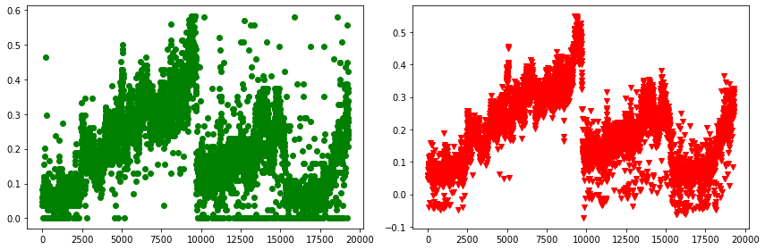

B.
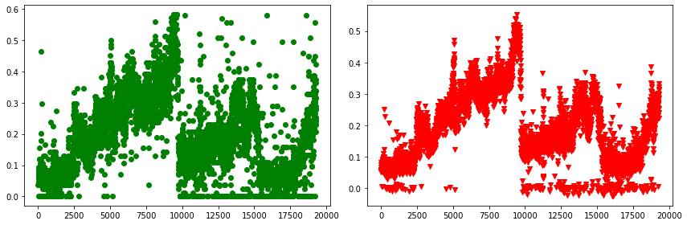

Figure. 4. A comparison between predicted and oridinal y_test (y-axis) vs. index (x-axis). Green represents the y_test and red represents y_pred_test. A- shows the model with fluorescence parameters. B. shows the models without.

